What is A Project Proposal?

A project proposal is a document that details a new project idea or improvement to the existing one. Its main objective is to communicate the idea, and what is needed to make it happen.

How to Write a Project Proposal.  
Step One: Define the Purpose around a Problem or Pain

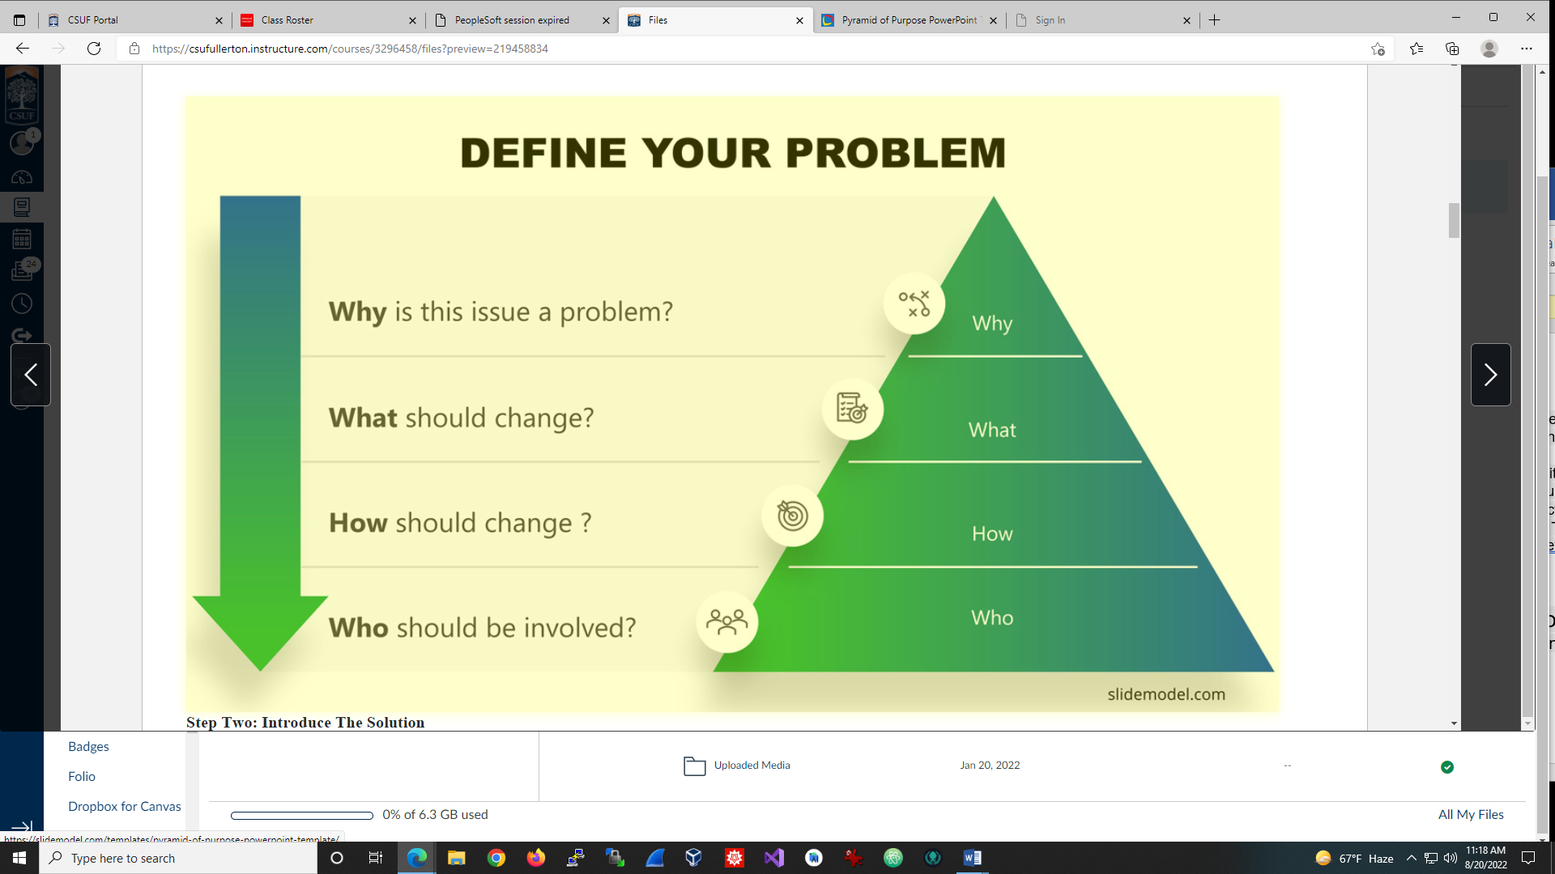

Step Two: Introduce the Solution

Now that you’ve hopefully convinced your audience of the existence of a problem, you now have to introduce the proposed solution.

Step Three: Specify Deliverables and Success Criteria

Deliverables are the results of your project. Think about it as the components, both tangible and intangible, that you’ll be delivering. Include the functions   
and characteristics of each deliverable, such as what it will do, how it will work, and what benefit it will have.

Step Four: Outline Project Resources  
Describe resource needed. For example, hardware, software, manpower

Step Five: Outline your Schedule  
Highlight start and end of the project, delivery dates and resources usage times.

Step Six: Executive Summary

Once the detailed version of your project proposal is complete, it’s time to summarize it into an executive summary. This summary will include a high-  
level list of each key element of your proposal. The idea of the executive summary is to be able to summarize in one page all the proposal, in a way an   
executive can grasp the overall scope.